# Group Assignment Proposal

## Group details

|  |  |
| --- | --- |
| Group number | 5 |
| Member names and UPIs | 1. Christynn Sim - schy192 2. Christopher Ham - sham708 3. Darren Wong - wwon158 4. Vincelia Wong - vwon786 5. Xinning Gong - xgon780 |
| Group name | Group 5 |
| System name | **X2C2D Web-Portal** |

## Module

The proposal is written to seek approval for a job-portal prototype for ‘X2C2D’ Career & Development agency. With the current pandemic situation in NZ, the agency was unable to normally operate. Hence, there is an opportunity for the agency to help New Zealand’s job-seekers connect with employers through a job-portal.

X2C2D agencies have several business needs; increasing the number of job applications for the company, increasing the efficiency of communication for employers and jobseekers, and transitioning into online presence. Our system will also support the agency requirements, such as allowing applicants to view employers' profiles and vice versa, allowing job searches to be filtered and a chat option that enables instant communication. Moreover, information will be collected in real-time and job seekers will be notified of job vacancies.

**Specific problems:**

1. A client who wants to modify their personal details must come into the agency to manually do so.
2. Lack of organisation in storing job listing and applications.
3. Applicant with company enquiries must go to the agency to seek help from the staff
4. It is difficult for the applicants to view on their hiring status and job application.
5. Applicants are not notified after their application status has changed

## Use case model

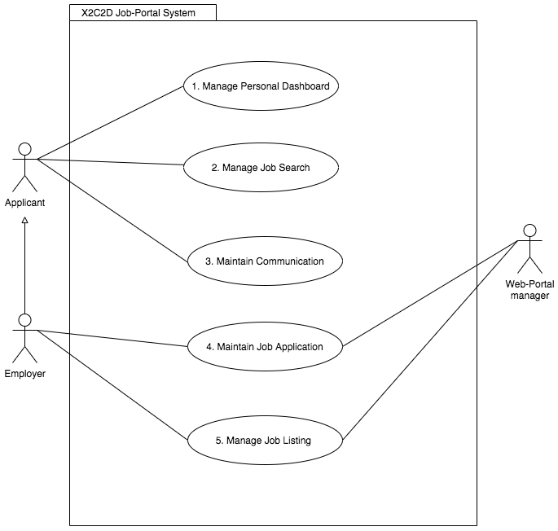

## Functions outline

|  |  |  |  |
| --- | --- | --- | --- |
| **Function number, name, and description** | **Function offered in which UC** | **Problem(s) solved by function** | **GUI details** |
| **F#1: Create Dashboard** enables applicants to change their dashboard from predefined categories (e.g change dashboard theme).  **F#2: Upload document** allow users to upload and store documents (e.g CV) on their profile.  **F#3:** **Edit information** allow users to change personal information such as users job experience and skills. | **UC#1:** Manage personal dashboard | **P#1:** Solved by allowing users to change their own information through the portal | **Offered in GUI**:1&2  **Used by:** Applicant & Employer |
| **F#1:** **Search jobs** allow users to search for available jobs using free text.  **F#2: Filter Search** allow users to filter their search results using predefined categories such as location, skills, job classifications.  **F#3: Add to watchlist** allow users to save jobs they are interested in and view them later. | **UC#2:** Manage job search | **P#2:** Solved by allowing users to filter through listings by categories  **P#4:** Solved by allowingapplicants to search and save potential jobs to apply later. | **Offered in GUI:**1&2  **Used by:** Applicant |
| **F#1: Create enquiry** allow applicants to discuss queries with employers through chat box.  **F#2:** **Send notification** allow employers to send notifications to inform about new job listings or events.  **F#3: Join Network** enables jobseekers to connect with potential employers based on contacts and connections they follow. | **UC#3:** Maintain communication | **P#2:** Solved by allowing applicants to ask for more information about the job  **P#5:** Solved by allowing employers to notify applicants that were not selected for the interview or getting hired. | **Offered in GUI:**1&2  **Used by:** Applicant & Employer |
| **F#1: Sort CV** enables employers to sort applicants’ CV’s from applicant’s chosen job classifications  **F#2:** **Rank Applications** enables employers to mark applications as potential or declined applicant  **F#3: View profile** enables employers to view submitted applicant’s profile | **UC#4:** Maintain job applications | **P#4:** Solved by viewing the job applicants CV and profile from the “submitted applications folder”  **P#5:** Solved by sending notification if the company has declined application | **Offered in GUI:** 1&2  **Used by:** Employer & Web-portal manager |
| **F#1:** **Post Job** allows employers to post job listings.  **F#2:** **Edit job listing** allows employers to edit job listings.  **F#3: Delete job listing** allows employers to delete job listings. | **UC#5:** Manage job listing | **P#4:** Solved by allowing employers to edit & delete listings once applicant/s have been hired | **Offered in GUI:** 1&2  **Used by:** Employer & Web-portal manager |

## Visual preview

**System GUI 1**: Desktop

**Users**: Applicant, Employer & Web-portal manager

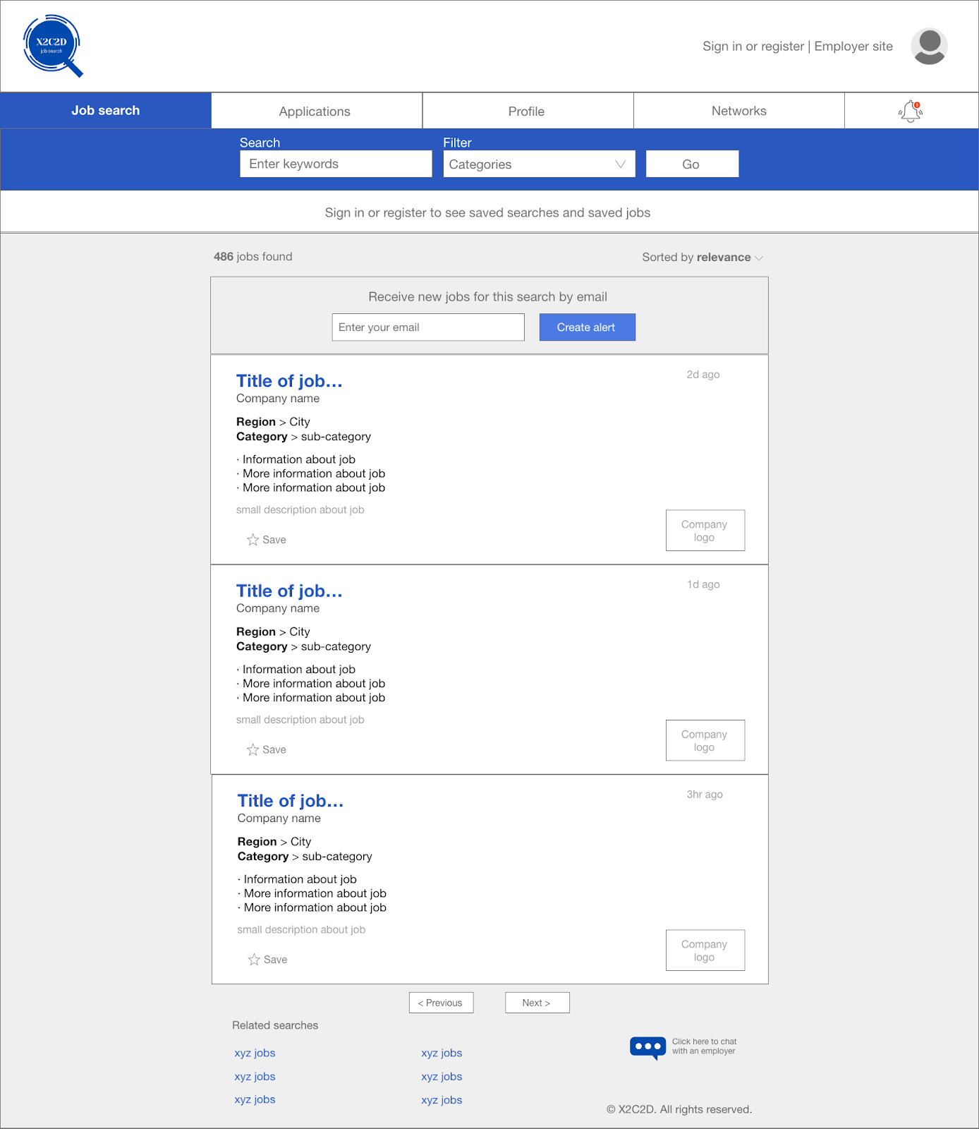

**System GUI 2**: Mobile App

**Users:** Applicant, Employer & Web-portal manager

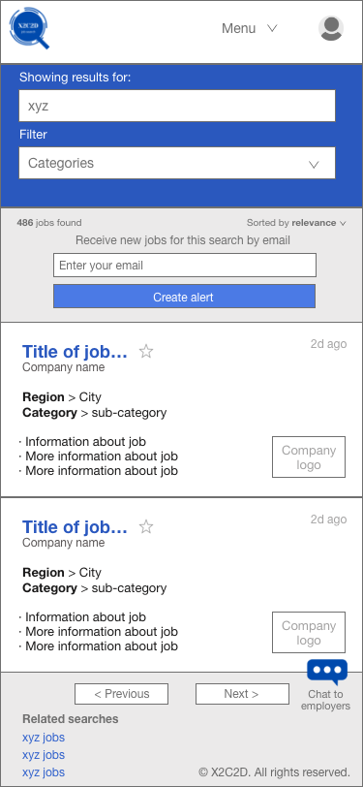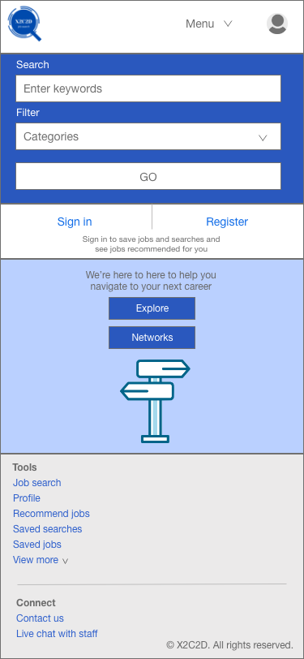

## Acknowledgement

All members of group 5 acknowledge that we understood the submission deadline

Word count: 687